PLEASE FILL IN THIS BOOKING FORM AND RETURN ASAP

NAME.................................................
ADDRESS.............................................................
............................................................................
.................................PHONE:................................
EMAIL..................................................................
PLEASE TICK WHAT APPLIES TO YOU:
I DON’T NEED ACCOMODATION........I NEED 1 NIGHT’S ACCOMODATION FRI/SAT...........I NEED 2 NIGHT’S ACCOMODATION FRI/SUN......I AM PREPARED TO SHARE A ROOM ......I HAVE MY OWN TRANSPORT.......
I AM A VEGETARIAN.......... I HAVE A SPECIAL DIET
(PLEASE SPECIFY).......................................................................

The conference fee is £35 (please send cheque made out to
The Christian Community with your application) or €40
(Please pay cash on arrival).
This pays for your food and accommodation.

Please send this booking form before the end of January to:
BEN VAN LIESHOUT
3 STEWARTS PLACE
HOLYWOOD
CO. DOWN
NORTHERN IRELAND
BT18 9DX

FOR ENQUIRIES:
TEL: 028 90424254
EMAIL: benvl@onetel.com

ANNUAL CONFERENCE
OF THE CHRISTIAN COMMUNITY
IN IRELAND
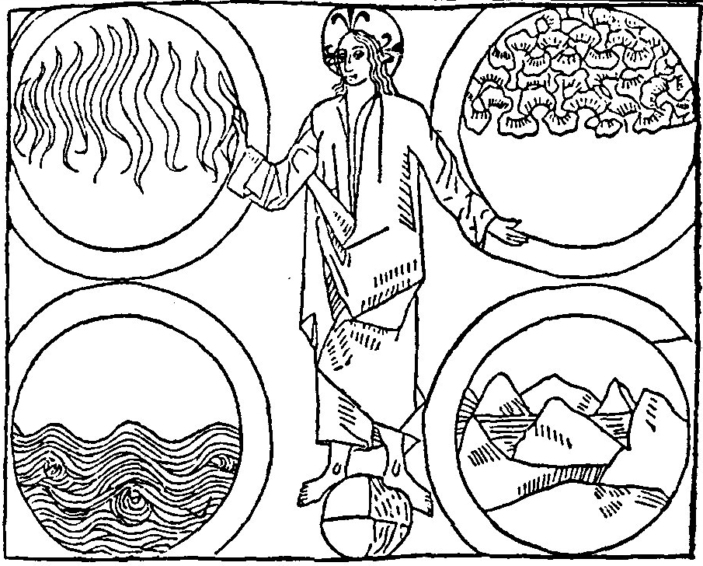

FINDING CHRIST’S LIGHT IN OUR DAY LIGHT;
FROM CELTIC CHRISTIANITY TO COSMIC CHRISTIANITY

FEBRUARY 17TH AND 18TH 2017
THE CHRISTIAN COMMUNITY
3 STEWARTS PLACE
HOLYWOOD
PROGRAMME
FRIDAY 17TH FEBRUARY
17.00 – 18.00 ARRIVAL AND REGISTRATION
18.00 - 19.00 COMMON SUPPER
19.30 – 20.30 WELCOME FOLLOWED BY CONTRIBUTIONS ON THE THEME
20.45 CLOSE OF DAY SERVICE
SATURDAY 18TH FEBRUARY
9.30 THE ACT OF CONSECRATION OF MAN
10.30 TEA BREAK
11.00 – 11.45 CONTRIBUTION ON THEME BY REV. TOM RAVETZ
12.00 – 12.45 CONVERSATION GROUPS ON THE THEME
13.00 LUNCH
14.15 - 15.00 ARTISTIC GROUPS: Celtic drawing with
Lisa Perry, Speech with Connor Jordan
and Singing with Eva van Lieshout

15.15 – 16.15 PLENUM AND SHARING FROM ALL OUR CONGREGATIONS
16.30 CLOSE OF DAY SERVICE
16.45 TEA BREAK
If you don’t want to travel back in the dark you can stay on for:
SUNDAY 19TH FEBRUARY
10.00 THE ACT OF CONSECRATION OF MAN
11.30 THE SUNDAY SERVICE FOR CHILDREN

The first Irish Christians called Christ the Lord of the Elements.
They perceived that the great Sun Spirit which they had always worshipped had now entered the life sphere of the earth.
This Celtic Christianity was carried all across Europe to rejuvenate the spiritual life there.
But Ireland slowly lost its unique heritage.
In our time we can find a new approach to the Lord of the Elements, a cosmic Christianity which sees Christ as the meaning of the earth.

