The Christian Community

Movement for religious renewal

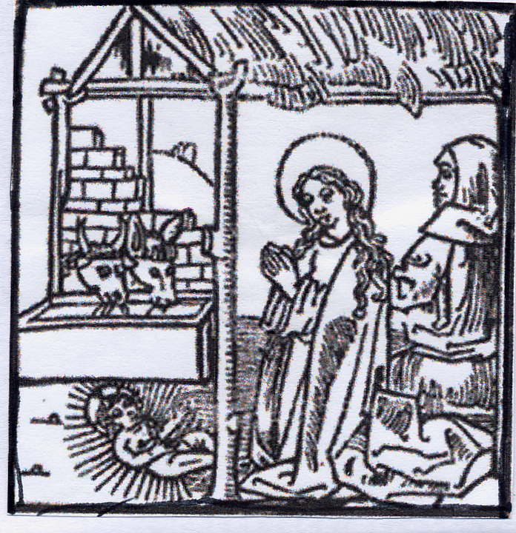

Advent, Christmas,

Epiphany,

February and March

2021-2022

Enquiries

The Christian Community

Priest

Rev Ben van Lieshout
3 Stewarts Place
Holywood, Co Down
BT18 9DX
Tel/Fax 028 90 424254
Mobile 07974960570
Email: benvl@onetel.com

Correspondents

Holywood: Jacinta McIlhone

Glencraig: Crispian Villeneuve

Mourne Grange: Karin Shea

Clanabogan: Brigitte de Rhoter

Ballybay: Colin Palmer

Treasurer
Richard Cooper

The Christian Community is funded entirely by donations of members and friends.
For details of standing orders and Gift Aid please contact our treasurer.
We warmly thank those who generously help our work through donations, regular contributions and legacies.
Holywood

Advent

Saturday 27th November Advent wreath making 16.30

Sunday 28th November Craft group 11.00-1600

Wednesday 1st December The Act of Consecration of Man 10.00

Sunday 5th December The Act of Consecration of Man 10.00
The Sunday Service for Children 11.30

Wednesday 8th December The Act of Consecration of Man 10.00

Sunday 12th December Fundraising at the School Advent Fair 13.00-18.00

Wednesday 15th December The Act of Consecration of Man 10.00

Sunday 19th December The Act of Consecration of Man 10.00
Talk and conversation:
“Coming in the realm of the clouds” 11.15

Wednesday 22nd December The Act of Consecration of Man 10.00

Christmas and the 12 holy nights

The Christmas Service for Children will be celebrated at 10.00 on Christmas day.
The Act of Consecration of Man at Christmas will be celebrated at midnight,
at 8.00 am and at 11.00 am on Christmas day.
And at 10.00 on Tuesday 28th , Wednesday 29th, Thursday 30th and Friday 31st and on Monday 3rd , Tuesday 4th and Wednesday 5th of January.

Other events:

Christmas Eve Gathering: for young and old, on 24th December at 17.00. Please bring a lantern to take your Christmas light home.

Christmas Course: After The Act of Consecration of Man on Tuesday 28^{th,} Wednesday 29th and Thursday 30th of December. We will meet around the Christmas tree with the theme: “Between the tree of knowledge and the tree of life“

New Year’s Eve Gathering: For young and old, on 31st of December at 20.00, ending with a Close of Day Service.

Epiphany

Sunday 9th January The Act of Consecration of Man 10.00
Talk and conversation: Communion :
“Medicine that makes whole” 11.15

Sunday 23rd January The Act of Consecration of Man 10.00
The Sunday Service for Children 11.30

Wednesday 26th January The Act of Consecration of Man 10.00

Thursday 27th January Finance group 20.00

Wednesday 2nd February The Act of Consecration of Man 10.00

February

Sunday 6th February The Act of Consecration of Man 10.00
Congregational meeting 11.15

Wednesday 9th February The Act of Consecration of Man 10.00

Wednesday 16th February The Act of Consecration of Man 10.00

Sunday 20th February The Act of Consecration of Man 10.00
The Sunday Service for Children 11.30

Wednesday 23rd FebruaryThe Act of Consecration of Man 10.00

March

Sunday 6th March The Act of Consecration of Man 10.00
Talk and conversation:
“Father , Son and ?: God and gender” 11.15

Wednesday 9th March The Act of Consecration of Man 10.00

Wednesday 16th March The Act of Consecration of Man 10.00

Confirmation preparation for Lucia and Jed, Thursdays at 15.20
on 2 and 9 December, 27 January, 3, 10 and 24 February
and 10 March.

Mourne Grange

Advent

Sunday 28th November The Act of Consecration of Man 10.15

Friday 10th December Talk: “Coming in the realm of the clouds” 16.00

Saturday 11th December The Act of Consecration of Man 10.15

Christmas

Monday 27th December The Act of Consecration of Man 10.15

Saturday 1st January The Act of Consecration of Man 10.15

Epiphany

Thursday 6th January The Act of Consecration of Man 10.15

Sunday 30th January The Act of Consecration of Man 10.15
Support Group 11.45

February

Saturday 12th February The Act of Consecration of Man 10.15

Friday 25th February Talk: “Father, Son and?, the gender of God” 16.00

Sunday 27th February The Act of Consecration of Man 10.15

March

Saturday 12th March The Act of Consecration of Man 10.15
Clanabogan

Advent

Friday 10th December Talk: “Coming in the realm of the clouds” 16.00

Sunday 12th December The Act of Consecration of Man 10.30

Christmas

Sunday 2ndJanuary The Act of Consecration of Man 10.30

Epiphany

Saturday 8th January The Act of Consecration of Man 10.30

February

Sunday 13th February The Act of Consecration of Man 10.30

March

Saturday 12th March Talk: “Father, Son and?, the gender of God”16.00

Sunday 13th March The Act of Consecration of Man 10.30

Glencraig

The Act of Consecration of Man will be celebrated on Thursdays at 9.30 On St Stephen’s Day, 26th December at 10.30.
But no Glencraig service on the 30th December, 6th, 13th and 20th of
January and also not on 3rd March.

Please contact the priest on 02890 424254 if you wish to
have a conversation or a sacramental consultation, prepare for a wedding or a baptism, make arrangements for a funeral, become a member, learn to serve, or simply want to find out more about The Christian Community.

Times Away

Ben van Lieshout will be away from the 11th to the 22nd of January for holidays and from 28 February – 4 March for a synod in London.
I will leave a message on my answerphone to let you know who you can contact in an emergency during my absence.

Gospel Readings

Advent: November 28 Luke 21 25-36
December 9 Luke 21 25-36
December 16 Luke 21 25-36
December 23 Luke 21 25-36

Christmas: Midnight Matthew 1-25
Dawn Luke 2 1-20
Day John 21 15-25
January 1 John 1 1-18

Epiphany: January 6 Matthew 2 1-12
January 9 Matthew 2 1-12
January 16 Luke 2 41-52
January 23 John 2 1-11
January 30 Luke 5 18-26

February: February 6 Matthew 8 5-13
February 13 Matthew 20 1-16
February 20 Luke 8 1-18
February 27 Luke 18 18-34

March: March 6 Matthew 4 1-11
March 13 Matthew 17 1-13

